Paris Olympics 2024 Data Analytics Project

SQL Queries & Results:

* Paris Olympics 2024 Statistics
  + Country who won the most medals:
    - SELECT country_code
    - FROM po2024.medals_total
    - WHERE Total = (SELECT MAX(Total) from po2024.medals_total);
    - 
  + Athlete who won the most medals
    - SELECT name, COUNT(*) AS total_medals
    - FROM po2024.medallists
    - GROUP BY name
    - ORDER BY total_medals DESC
    - LIMIT 1;
    - 
  + Amount of athletes competing
    - SELECT count(name) as total_athletes
    - FROM po2024.athletes;
    - 
  + Amount of countries competing
    - SELECT count(distinct country) as total_countries
    - FROM po2024.athletes;
    - 
* Top 2 Teams Medal Trends Per Day
  + USA Daily Medal Trend
    - SELECT STR_TO_DATE(medal_date, '%m/%d/%Y') AS Date, SUM(Medal_per_team) AS Medals_Earned
    - FROM po2024.medallists
    - WHERE country_code = 'USA'
    - GROUP BY STR_TO_DATE(medal_date, '%m/%d/%Y')
    - ORDER BY STR_TO_DATE(medal_date, '%m/%d/%Y');
    - 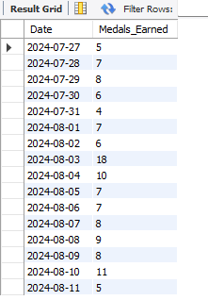
  + CHINA Daily Medal Trend
    - SELECT STR_TO_DATE(medal_date, '%m/%d/%Y') AS Date, SUM(Medal_per_team) AS Medals_Earned
    - FROM po2024.medallists
    - WHERE country_code = 'CHN'
    - GROUP BY STR_TO_DATE(medal_date, '%m/%d/%Y')
    - ORDER BY STR_TO_DATE(medal_date, '%m/%d/%Y');
    - 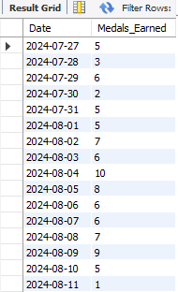
* Host Country Statistics
  + France Daily Medal Trend
    - SELECT STR_TO_DATE(medal_date, '%m/%d/%Y') AS Date, SUM(Medal_per_team) AS Medals_Earned
    - FROM po2024.medallists
    - WHERE country_code = 'FRA'
    - GROUP BY STR_TO_DATE(medal_date, '%m/%d/%Y')
    - ORDER BY STR_TO_DATE(medal_date, '%m/%d/%Y');
    - 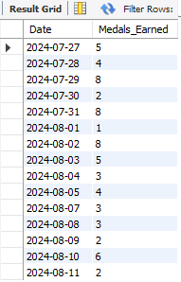
  + France Top Sports/Disciplines
    - SELECT discipline, SUM(Medal_per_team) AS Medals_Earned
    - FROM po2024.medallists
    - WHERE country_code = 'FRA'
    - GROUP BY discipline
    - ORDER BY Medals_Earned DESC;
    - 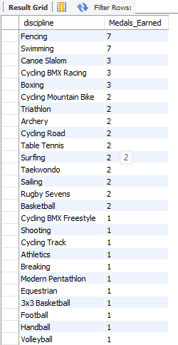
  + France Male and Female Medalist Percentage
    - SELECT gender, COUNT(*) * 100.0 / (SELECT COUNT(*) FROM po2024.medallists WHERE country_code = 'FRA') AS percentage
    - FROM po2024.medallists
    - WHERE country_code = 'FRA'
    - GROUP BY gender;
    - 